Chapter 17, Problem 30.

- If f(t) is an even function, show that 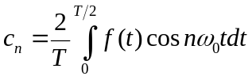
- If f(t) is an odd function, show that 